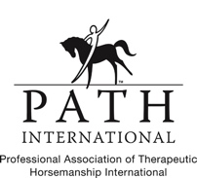
The Carriage Barn Equestrian Center
2019 Fall Programs
Mailing Address: Phone: 603-378-0140
PO Box 247 carriage-barn@comcast.net
East Kingston, NH 03827 www.carriage-barn.org

The Carriage Barn Equine Assisted Therapy Programs seek to promote the health and well-being of individuals of all ages with disabilities by enhancing their physical, psychological, cognitive and emotional healing and strengthening through equine activities. Our program activities further this purpose by utilizing horses to provide opportunities for participants to form unique relationships that nurture and empower them in a way that brings new insights, self-confidence, improved communication, and relaxation to their lives. In the context of a quiet, natural outdoor setting, these equine activities provide our participants with a serene learning environment.
*Please return registration forms via email to carriage-barn@comcast.net or by mail to The Carriage Barn, P.O. Box 247, East Kingston, NH, 03827. Checks should be made out to The Carriage Barn and mailed to our P.O. Box address*.
*All our programs take place at The Carriage Barn located at 10 Trundlebed Lane Kensington, NH, 03833*.
Youth Programs
Beginner Riding Lessons: Is your son or daughter interested in learning how to ride a horse? This inclusive beginner riding program is for children ages 5 to 18 years old. Each session will be one hour for four weeks during the month of September. Your child will learn the basics of grooming, tacking, and riding a horse.
When: Beginning September 4th 2019, Wednesdays from 3:30pm to 4:30 pm or 5:00pm to 6:00pm
Cost: $160 per child
Aftercare: Pick-up will be at 4:30pm and 6:00pm respectively, but if you are unable to pick-up your child at that time, we will provide aftercare past 4:30pm/6:00pm. Aftercare will end no later than 6:30pm! Aftercare will cost an additional $15 dollars per hour.

Live, Laugh, Love, & Be Happy Weekly Group: The program will be geared towards positively impacting the lives of children, youth, and adolescents dealing with anxiety, depression, and suicide. Participants will build their confidence and sense of competence, develop their problem solving and decision making skills, and strengthen their coping skills. They will also be encouraged to communicate and show others empathy. This program will be run by the Executive Director Ann Miles, Ph.D. and will begin in September 2019.
When: Beginning September 7th 2019, Saturday mornings from 10:00am – 12:00pm
Cost: $160 per participant monthly or $50 per drop-in session
Adult Programs
Adult Recreational Riding: Are you interested in learning how to ride a horse? The Carriage Barn will be providing inclusive recreational riding lessons for adults ages 18+. There will be two different session days, one will be Tuesday evening and the other will be Saturday afternoon. Each session will be two hours for four weeks during the month of September. Attendees will learn the basics of grooming, tacking, and riding a horse.
When: Beginning September 3th 2019, Tuesday evenings from 6:00pm to 8:00pm.
When: Beginning September 7th 2019, Saturday afternoons from 1:00pm to 3:00pm or 3:00pm to 5:00pm.
Cost: $100 per adult
Adult Equine Education Class: Join our inclusive adult equine education class! In this class attendees will learn about various aspects of horses, such as horse care, behavior modification, and history. This inclusive hands on horse management class will review the most popular horse disciplines, including western, English, bareback, and training techniques. We will be using a book called The Horse by Wendy Williams, which gives the history of horses from 2000 B.C. to present day. Each session will be two hours for four weeks during the month of September.
When: Beginning September 15th 2019, Sunday afternoons from 2:00pm to 4:00pm.
Cost: $800 per adult
Adult Carriage Driving: If riding a horse isn’t for you, but you still want to interact with a horse then come join our inclusive adult carriage driving program! Each session will be two hours for four weeks during the month of September. Adults 18+ will learn how to groom, tack, and carriage drive one of our many horses.
When: Beginning September 1st 2019, Sunday mornings from 10:00am to 12:00pm or from 11:00am to 1:00pm (bring a lunch!).
Cost: $100 per adult
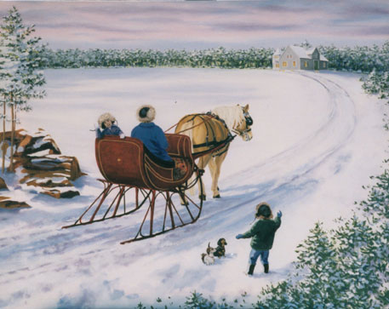
Holiday Sleigh Ride: Have you ever been in a sleigh pulled by a horse? Have you ever wanted to try driving in the sleigh yourself? Here is your opportunity! The Carriage Barn is offering a holiday sleighing experience and snow tubing. Sleighing times will be scheduled once there is snow on the ground. Each sleigh ride will be approximately 30 minutes to an hour. Please complete the registration form and mail it to us (see above) if you are interested in this experience.
When: December, depending upon the weather.
Cost: $150 per adult

* Cancellation Policy: This applies to all of our fall programs. You must let us know 24 hours in advance if you are unable to attend a session. If we do not hear from you 24 hours in advance, there will be a cancelation fee of $15*.

